Troubleshooting Steps:

1. Account A: account in which I have the data
2. Account B: account in which I have my DynamoDB table(My account)

* I created a s3:// yaswanth-dydb-impexport in the account A
* Created a bucket policy and gave access to the roles DatapipelineDefaultRole and datapiplelineDefaultResourceRole(so that EMR cluster and the datapipline access this bucket) as shown in the below screen shot:

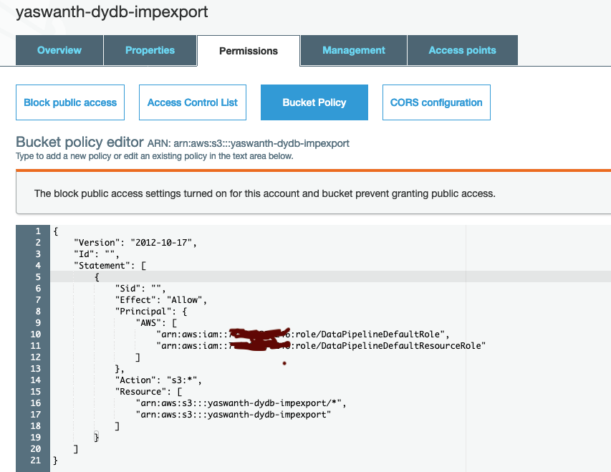

* Created a data pipeline in account B
* Created an IAM Policy as shown below and attached this policy to the Roles “DatapipelineDefaultRole” and “DatapipelineDefaultRole”
* With this permission I am allowing the roles to access the bucket in another account and I have below permissions on the bucket, which is in account A.

"s3:AbortMultipartUpload",

"s3:GetBucketLocation",

"s3:GetObject",

"s3:ListBucket",

"s3:ListBucketMultipartUploads",

"s3:PutObject"

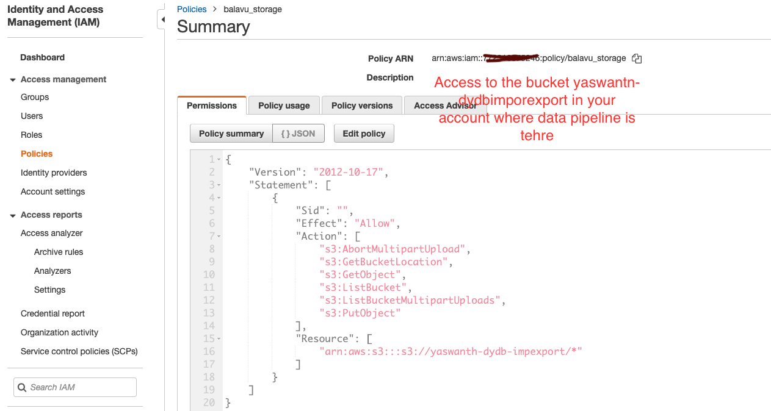

Exporting data from DynamoDB to s3://yaswanth-dydb-impexport

* DynamoDB table name: mydetails
* S3 path: s3://yaswanth-dydb-impexport/
* The data is exported to s3 the files are as shown in the below screen shot:

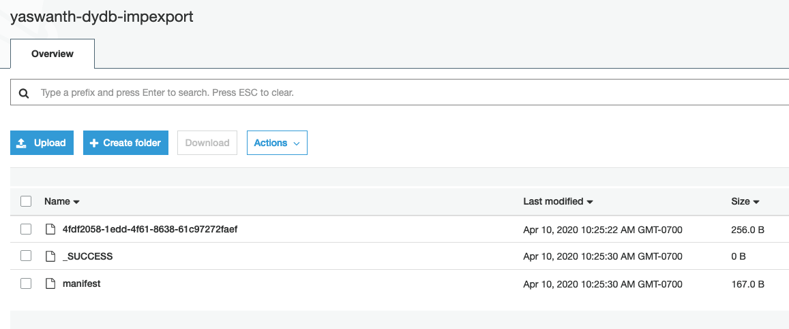

Importing data from s3:// to DynamoDB table

* To replicate the importing I deleted the items in DynamoDB table and imported the data from the bucket, the datapipeline configurations are in the below screenshot
* I can successfully import the data into DynamoDB table.

